1. 验证每种事务隔离级别的影响脏读，不可充重复读，幻读，更新丢失
2. 脏读：
   1. 代码：先提交事务一再提交事务2

事务1：

**BEGIN**;

**SET** **TRANSACTION** **ISOLATION** **LEVEL** **READ** **UNCOMMITTED**;

**show** transaction_isolation;

**SELECT** * **FROM** students;

**SELECT** * **FROM** students **WHERE** id=1;

**SELECT** pg_sleep(10);

**SELECT** * **FROM** students;

**SELECT** * **FROM** students **WHERE** id=1;

**COMMIT**;

事务2：

**BEGIN**;

**SET** **TRANSACTION** **ISOLATION** **LEVEL** **READ** **UNCOMMITTED**;

**show** transaction_isolation;

**UPDATE** students **SET** score=score+10 **WHERE** ID=1;

*--SAVEPOINT s;*

**SELECT** * **FROM** students **WHERE** id=1;

**SELECT** pg_sleep(10);

**COMMIT**;

* 1. 各隔离级别下的验证结果：任何隔离级别下都不脏读

READ UNCOMMITTED

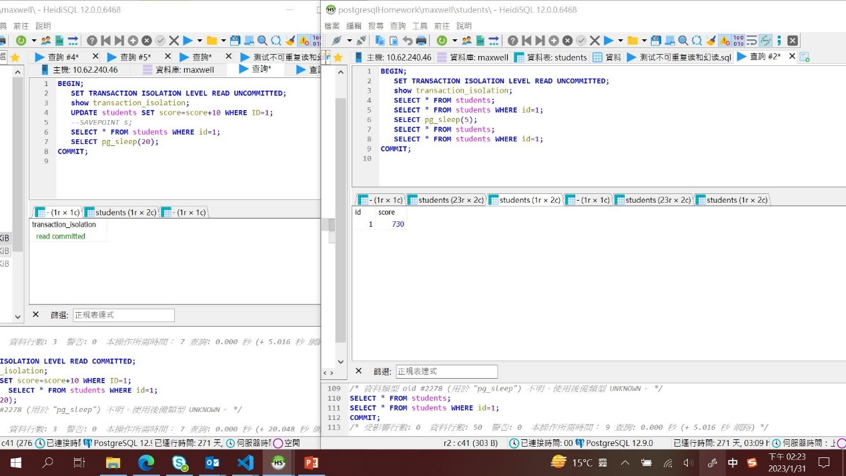

READ COMMITTED

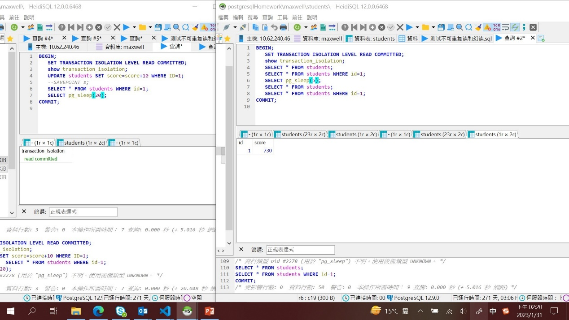

REPEATABLE READ

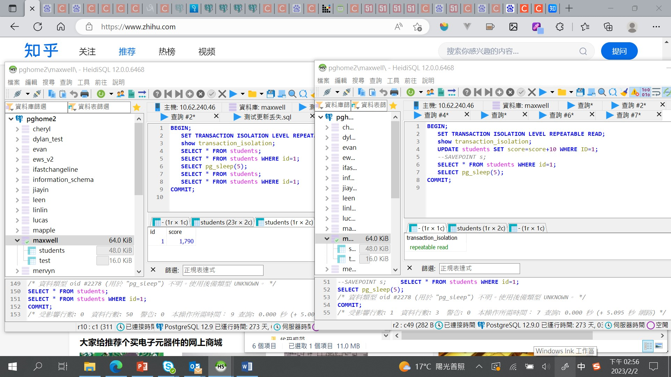

SERIALIZABLE

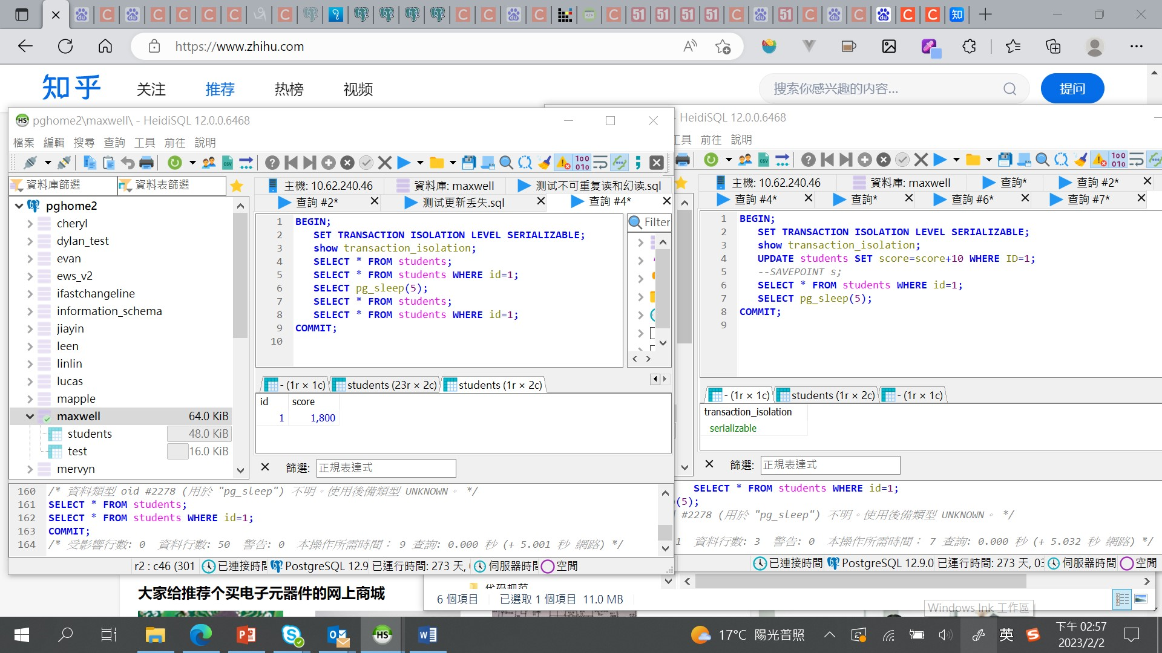

1. 幻读：
   1. 代码：

事务1：

**BEGIN**;

**SET** **TRANSACTION** **ISOLATION** **LEVEL** **READ** **UNCOMMITTED**;

**show** transaction_isolation;

**SELECT** * **FROM** students;

**SELECT** * **FROM** students **WHERE** id=1;

**SELECT** pg_sleep(10);

**SELECT** * **FROM** students;

**SELECT** * **FROM** students **WHERE** id=1;

**COMMIT**;

事务2：

**BEGIN**;

**SET** **TRANSACTION** **ISOLATION** **LEVEL** **READ** **UNCOMMITTED**;

**show** transaction_isolation;

**INSERT** **INTO** students(Score) **VALUES**(99);

**SAVEPOINT** s;

**SELECT** * **FROM** students;

**COMMIT**;

* 1. 各隔离级别下的验证结果：只在Read Uncommitted和Read Committed隔离级别下发生

READ UNCOMMITTED

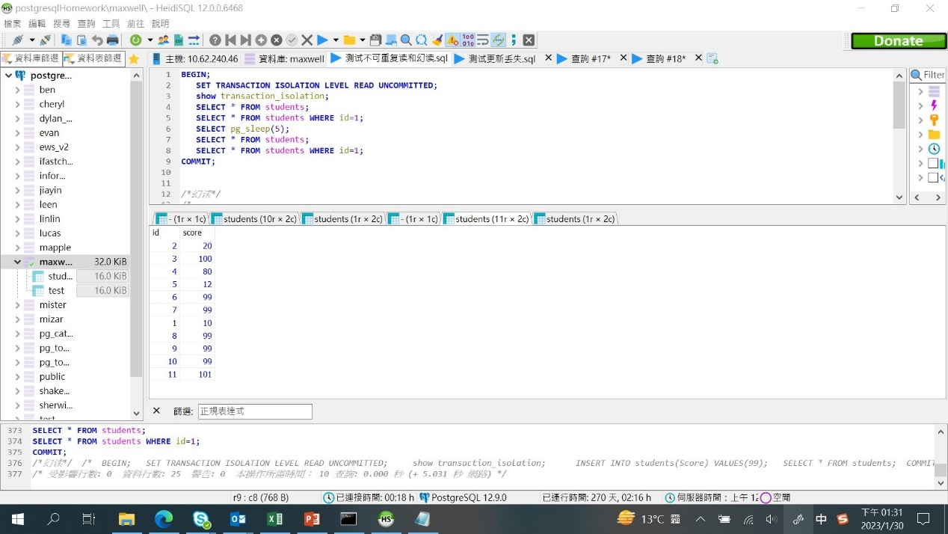

READ COMMITTED 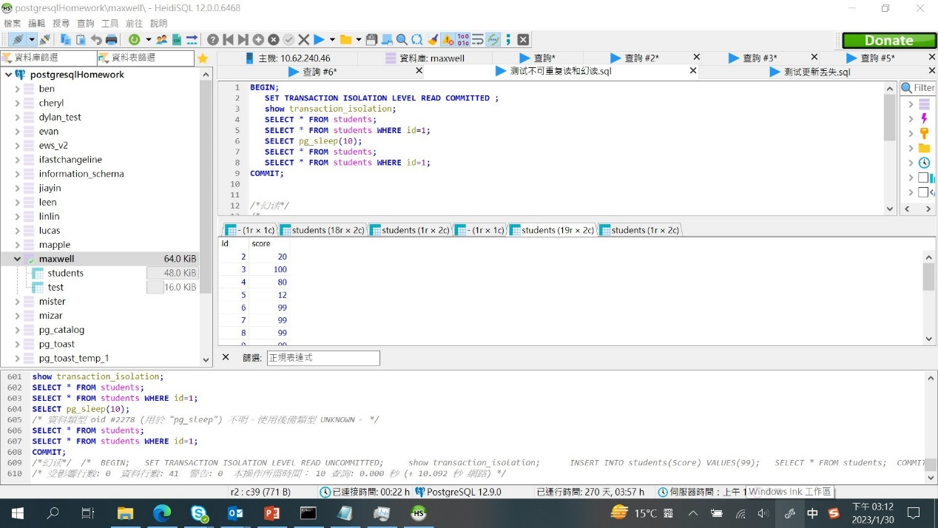

REPEATABLE READ

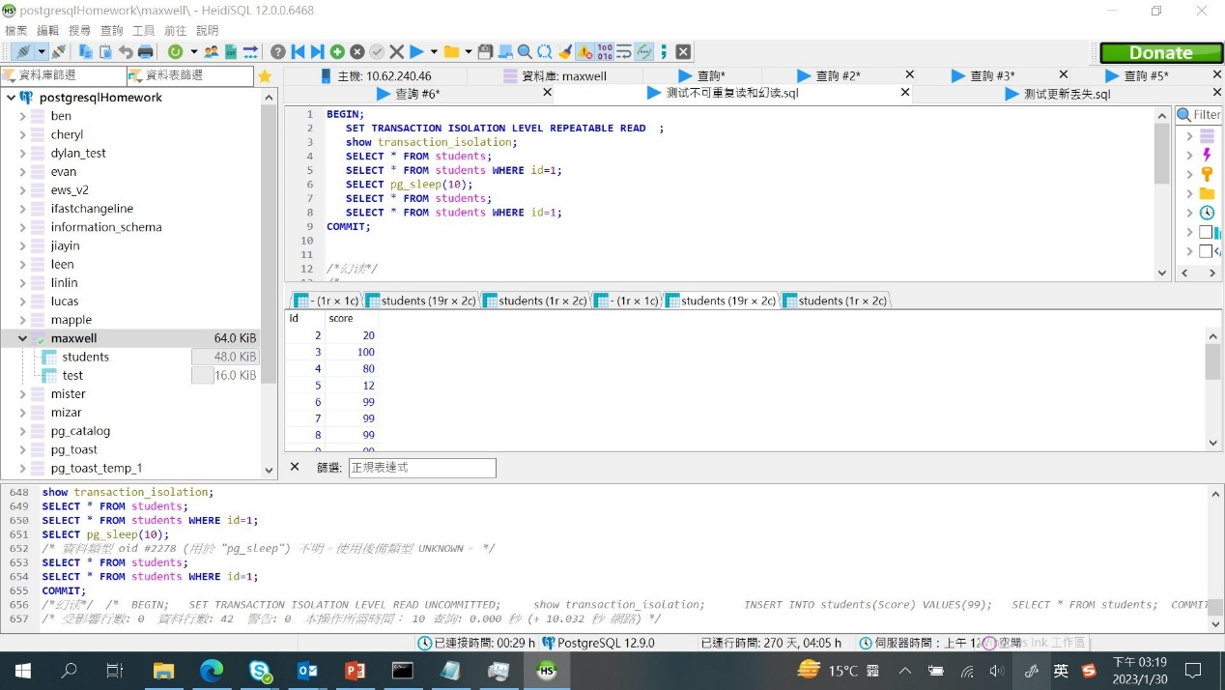

SERIALIZABLE

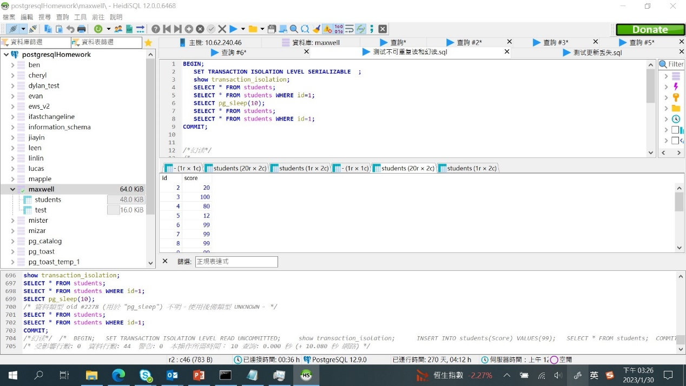

1. 不可重复读

3.1．代码：

事务1：

**BEGIN**;

**SET** **TRANSACTION** **ISOLATION** **LEVEL** **READ** **UNCOMMITTED**;

**show** transaction_isolation;

**INSERT** **INTO** students(Score) **VALUES**(99);

**SAVEPOINT** s;

**SELECT** * **FROM** students;

**COMMIT**;

事务2:

**BEGIN**;

**SET** **TRANSACTION** **ISOLATION** **LEVEL** **READ** **UNCOMMITTED**;

**show** transaction_isolation;

**UPDATE** students **SET** score=score+10 **WHERE** ID=1;

*--SAVEPOINT s;*

**SELECT** * **FROM** students **WHERE** id=1;

**COMMIT**;

* 1. 验证结果：只在Read Uncommitted和Read Committed隔离级别下发生

READ UNCOMMITTED

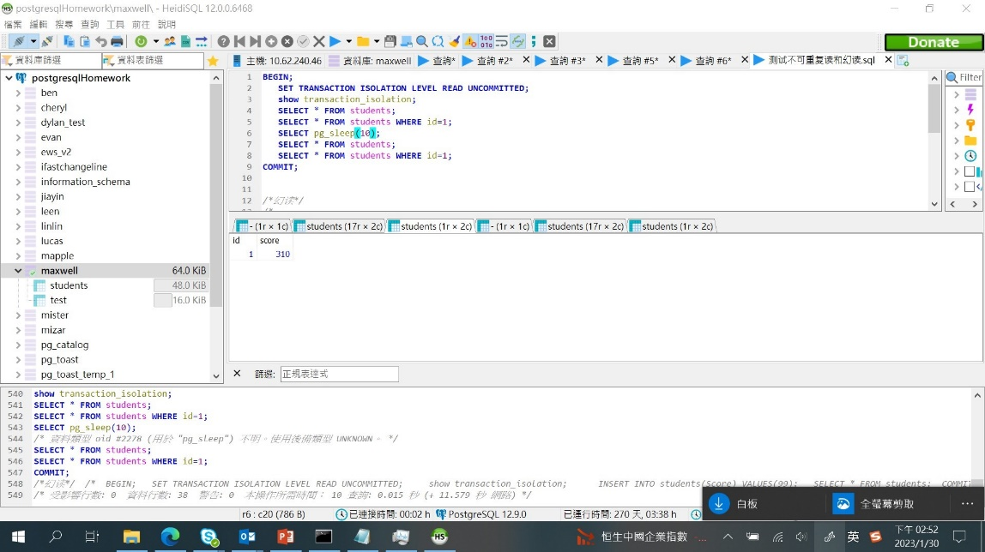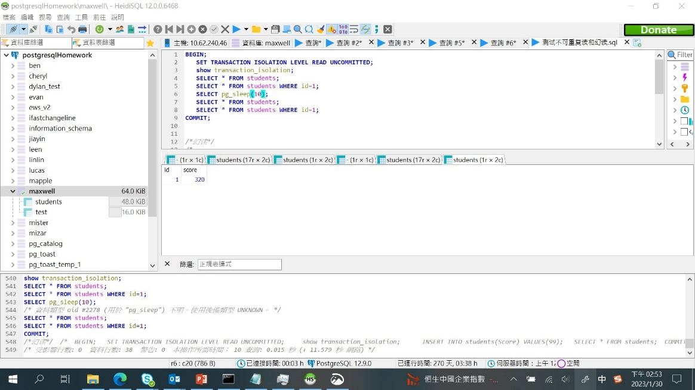

READ COMMITTED

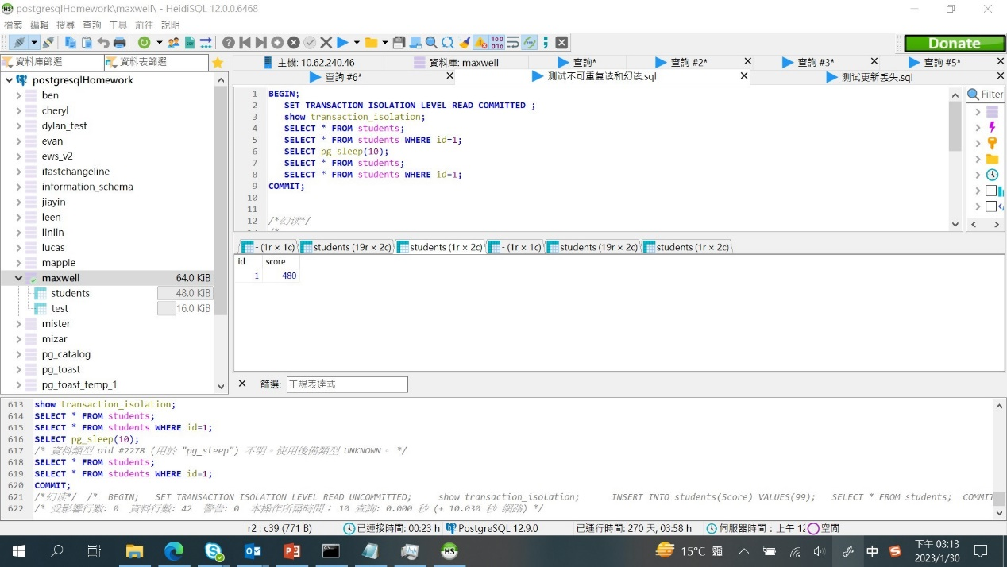

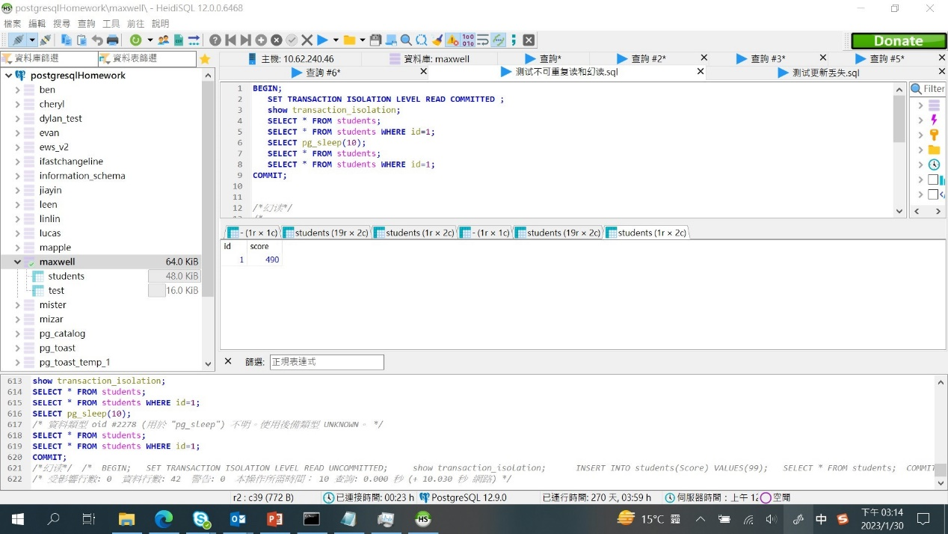

REPEATABLE READ

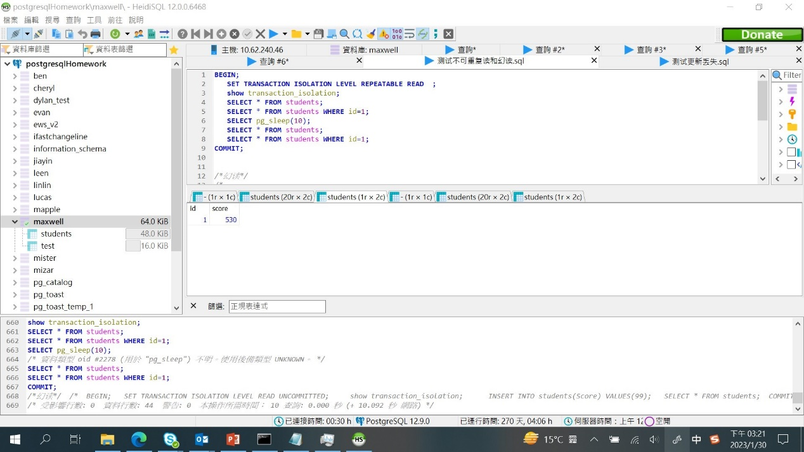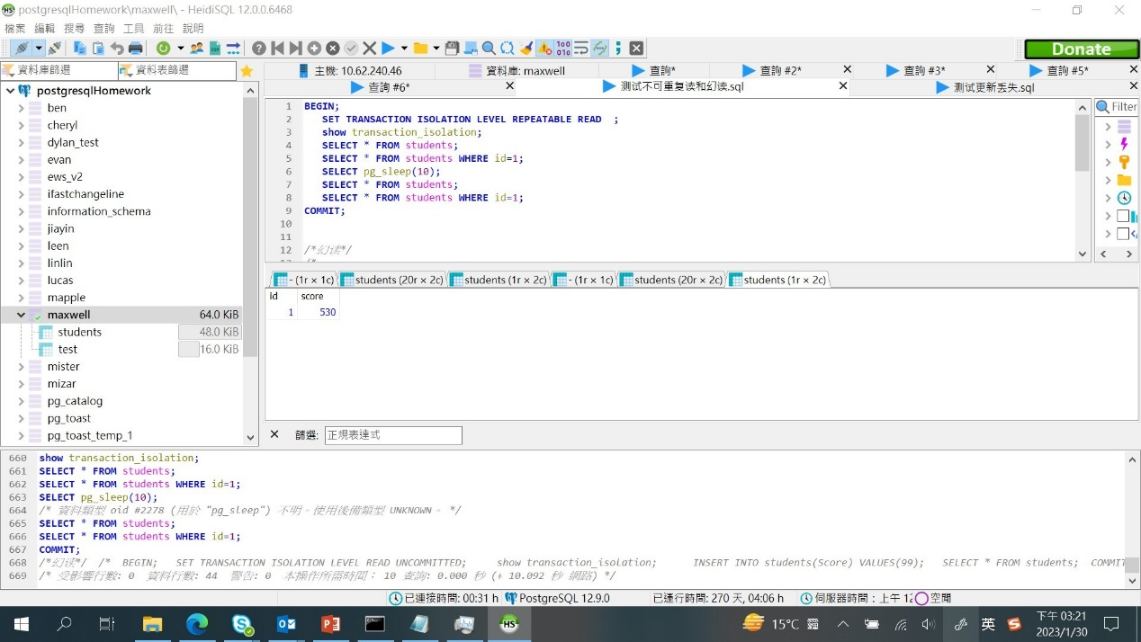

SERIALIZABLE

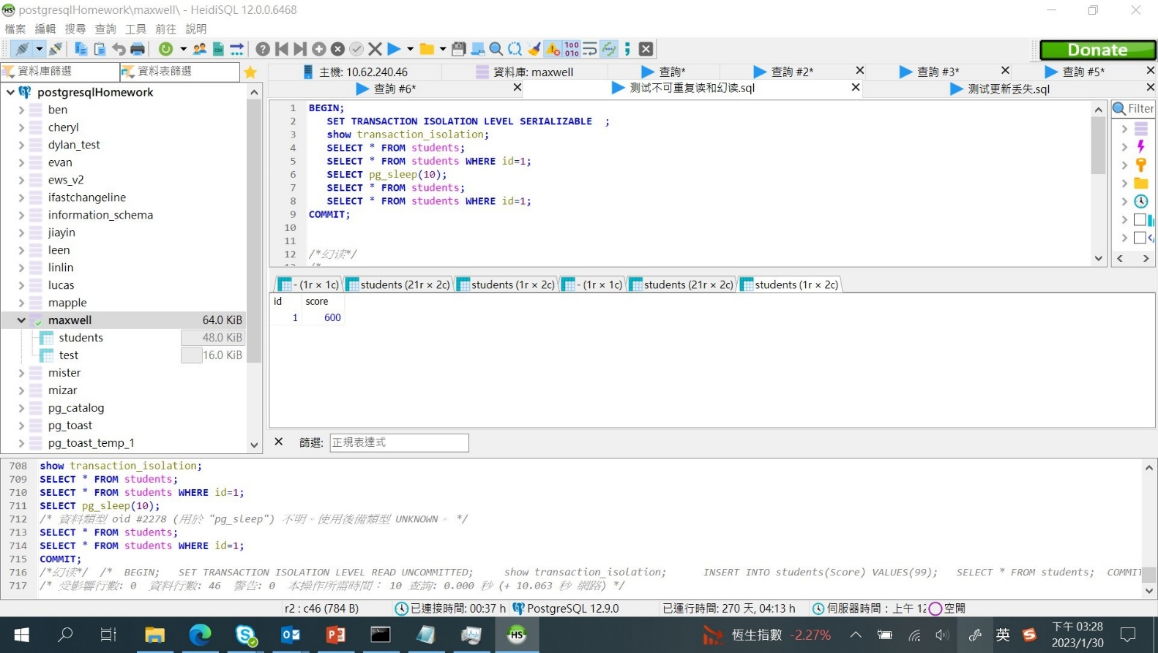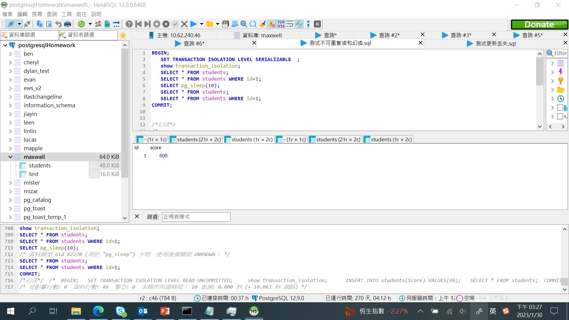

1. 丢失更新
   1. 代码：

事务1：

**BEGIN**;

**SET** **TRANSACTION** **ISOLATION** **LEVEL** **SERIALIZABLE** ;

**show** transaction_isolation;

**SELECT** * **FROM** students **WHERE** id=1;

**UPDATE** students **SET** score=score+30 **WHERE** ID=1;

**SELECT** pg_sleep(10);

**SAVEPOINT** s;

**SELECT** * **FROM** students **WHERE** id=1;

**COMMIT**;

事务2：

**BEGIN**;

**SET** **TRANSACTION** **ISOLATION** **LEVEL** **READ** **UNCOMMITTED**;

**show** transaction_isolation;

**UPDATE** students **SET** score=score+10 **WHERE** ID=1;

**COMMIT**;

4.2．验证结果：postgresql在任何级别下都不会发生丢失更新的现象，但在REPEATABLE READ和SERIALIZABLE隔离级别下会拒绝事务2的执行。参考[MVCC in PostgreSQL — 1. Isolation : Postgres Professional](https://postgrespro.com/blog/pgsql/5967856)和[PostgreSQL: Documentation: 12: 13.2. Transaction Isolation](https://www.postgresql.org/docs/12/transaction-iso.html" \l "XACT-SERIALIZABLE)。

READ UNCOMMITTED

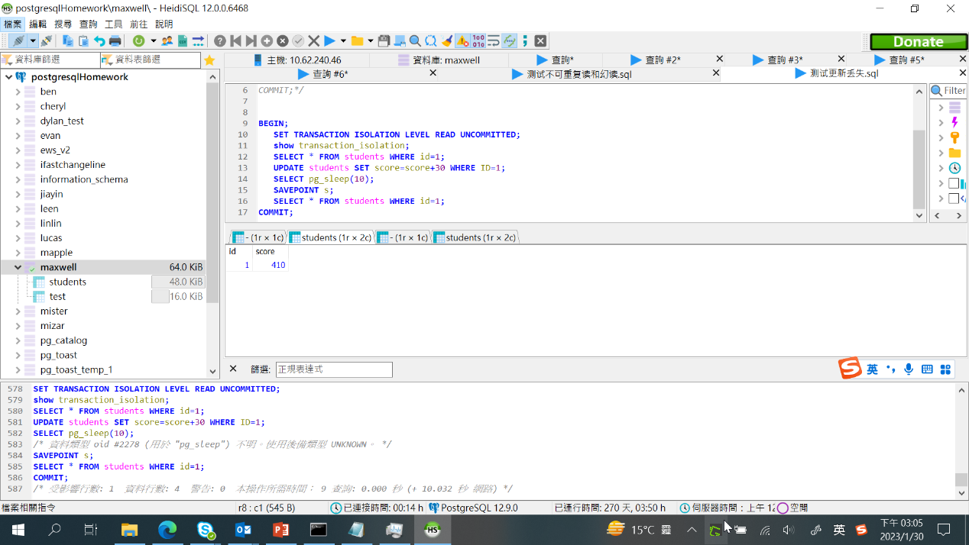

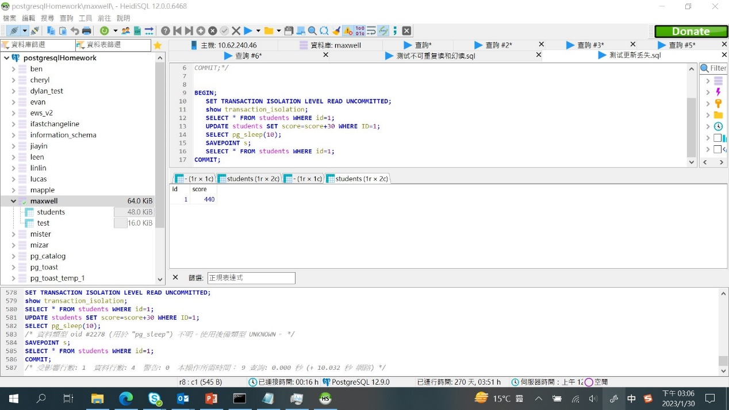

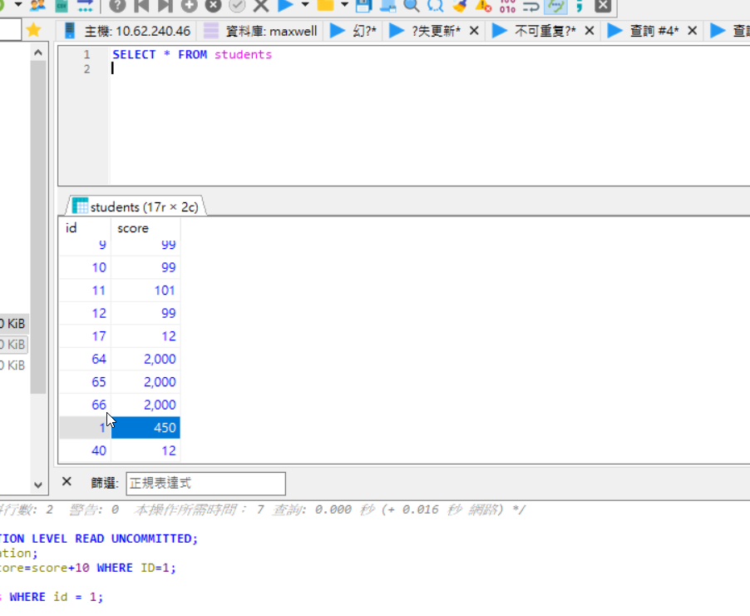

READ COMMITTED

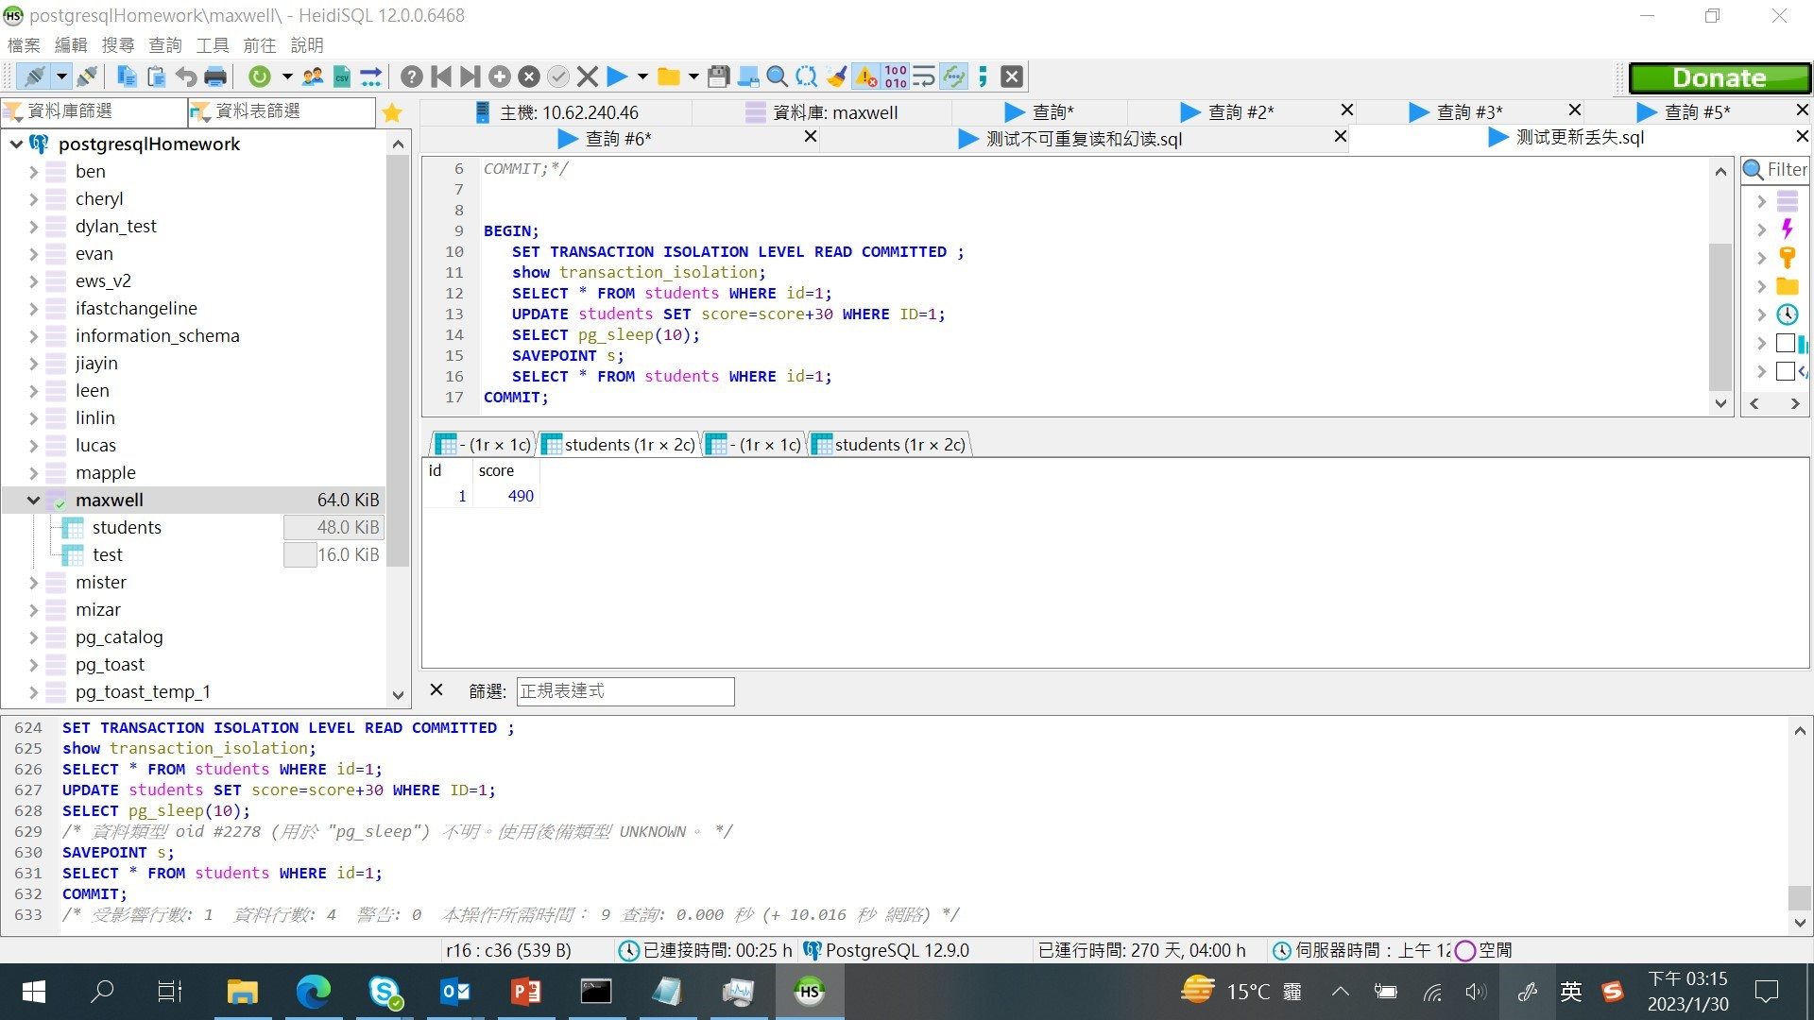

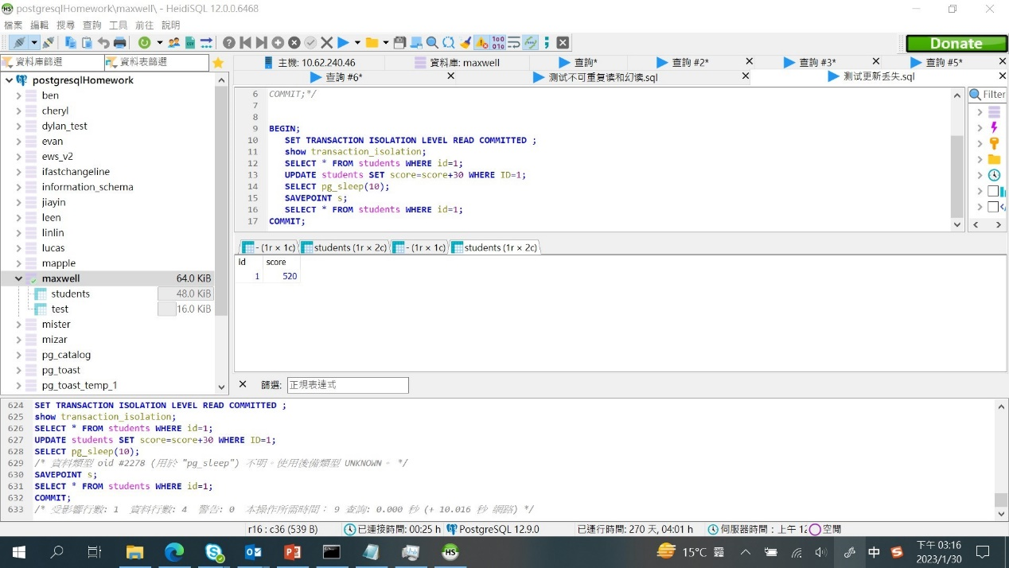

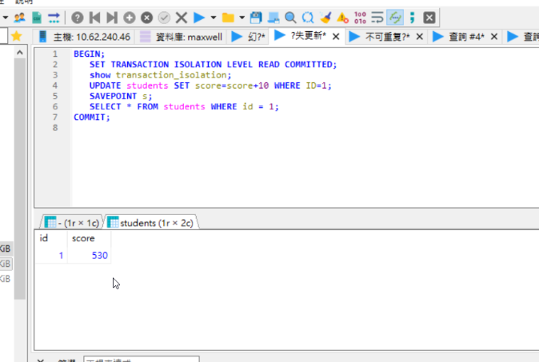

REPEATABLE READ

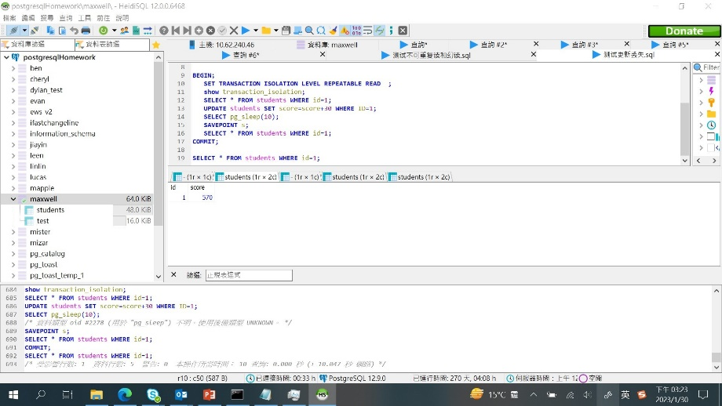

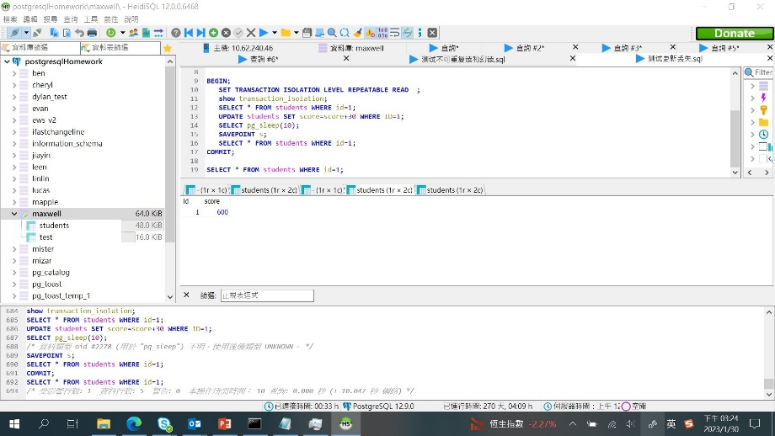

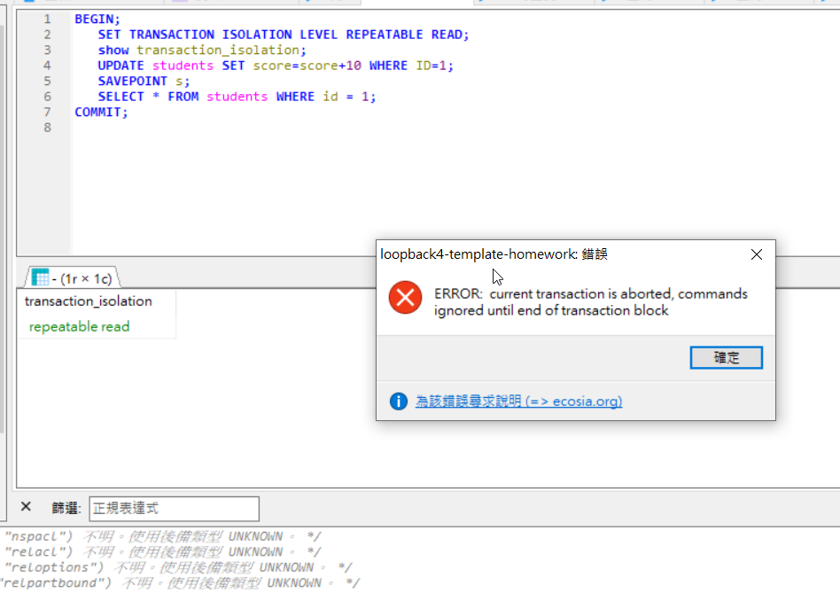

SERIALIZABLE

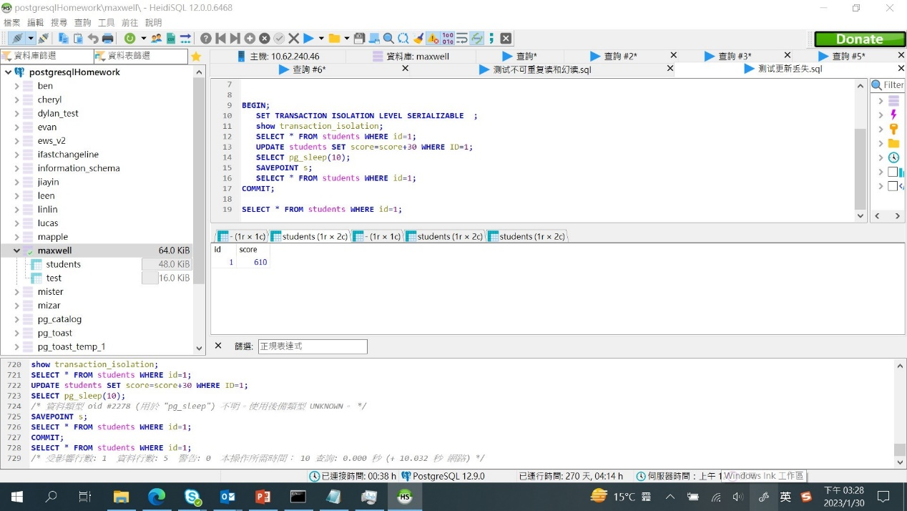

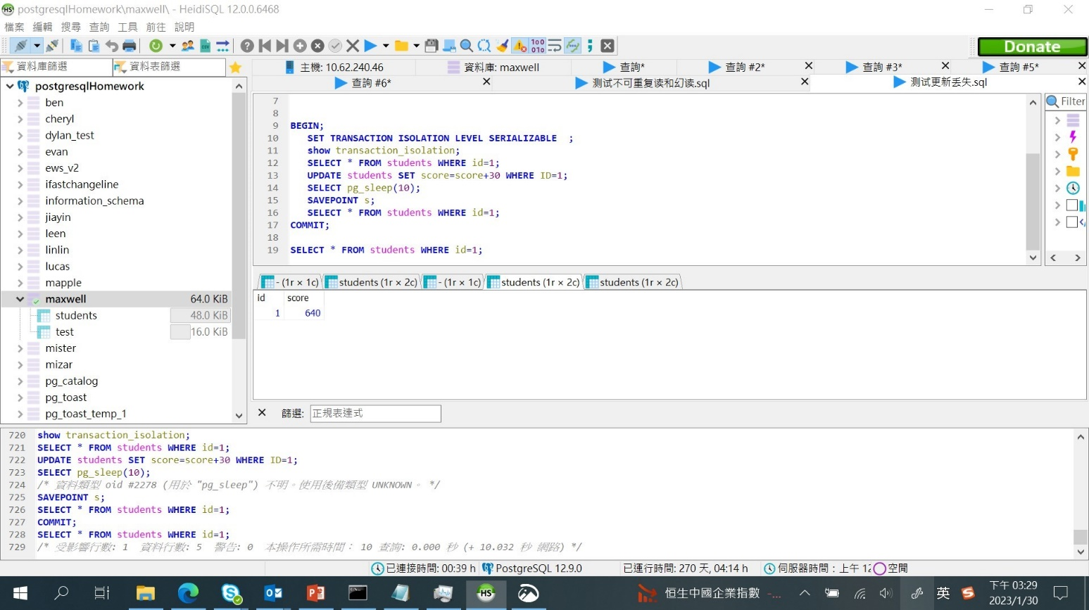

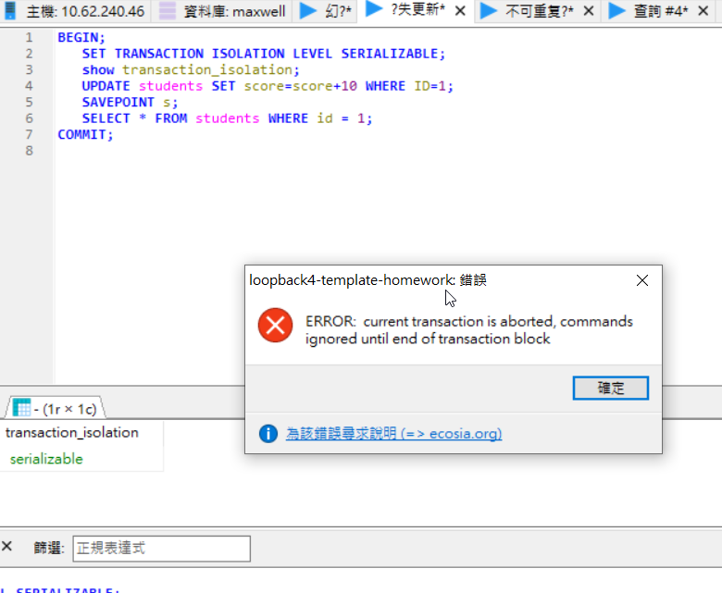

1. 查询系统表每种事务隔离级别的Locked， locked type (可读可写，可读不写，不可读不写)及locked作用范围(锁表，锁行，锁列)。
2. 代码

**BEGIN**;

**SET** **TRANSACTION** **ISOLATION** **LEVEL** */*SERIALIZABLE*/* */*READ COMMITTED*/* */*REPEATABLE READ*/* **READ** **UNCOMMITTED** ;

**show** transaction_isolation;

**select** * **from** pg_locks **WHERE** **DATABASE**=42799;

**select** txid_current();

**SELECT** * **FROM** pg_database;

**SELECT** * **FROM** students **WHERE** id=1;

**UPDATE** students **SET** score=score+20 **WHERE** ID=1;

**SELECT** * **FROM** pg_class;

**select** * **from** pg_locks **WHERE** **DATABASE**=42799;

**COMMIT**;

1. 运行结果：

READ UNCOMMITTED

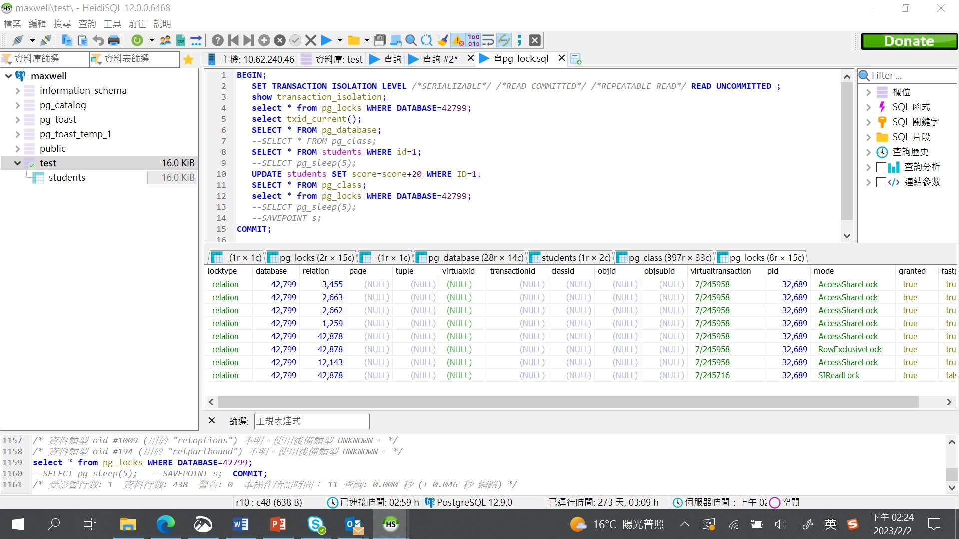

READ COMMITTED

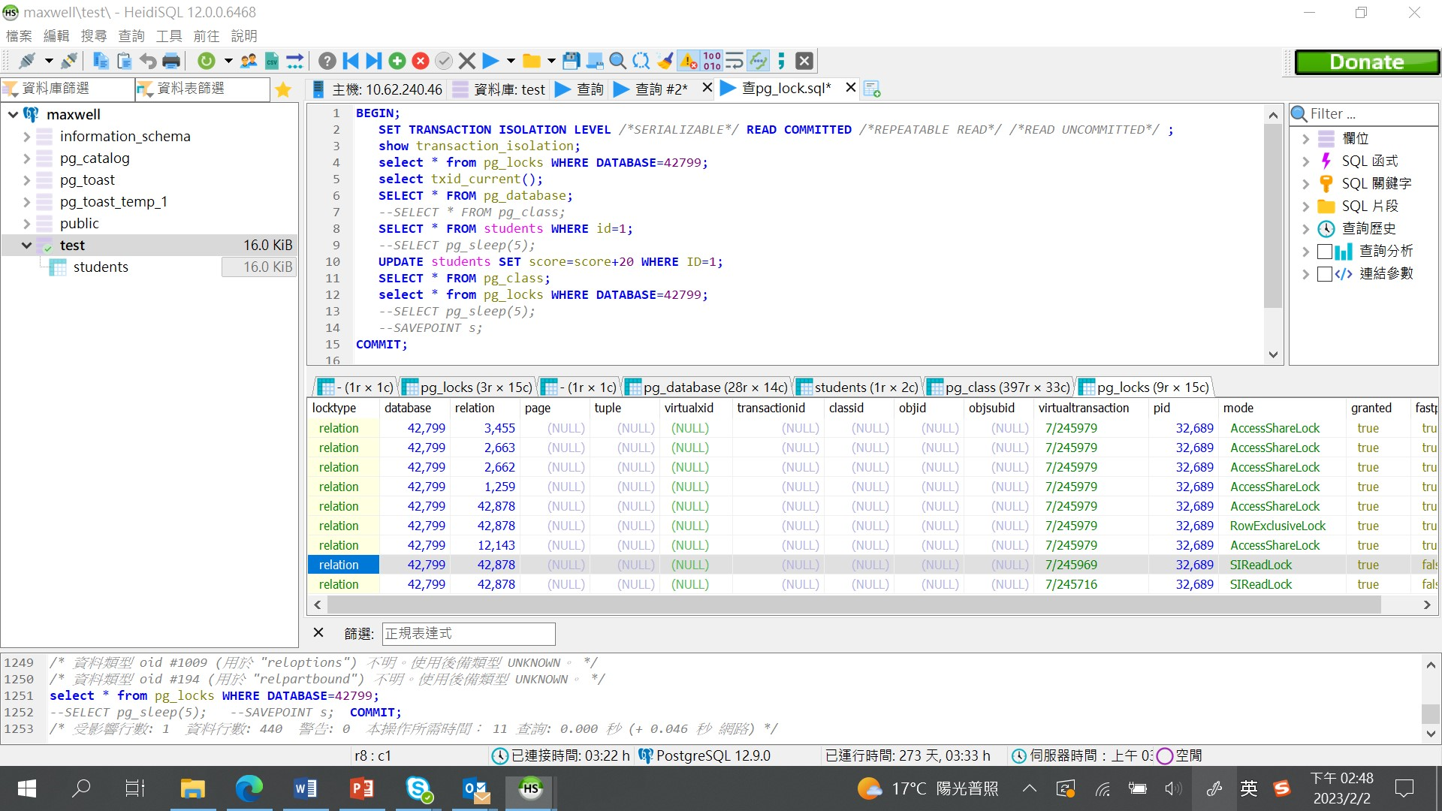

REPEATABLE READ

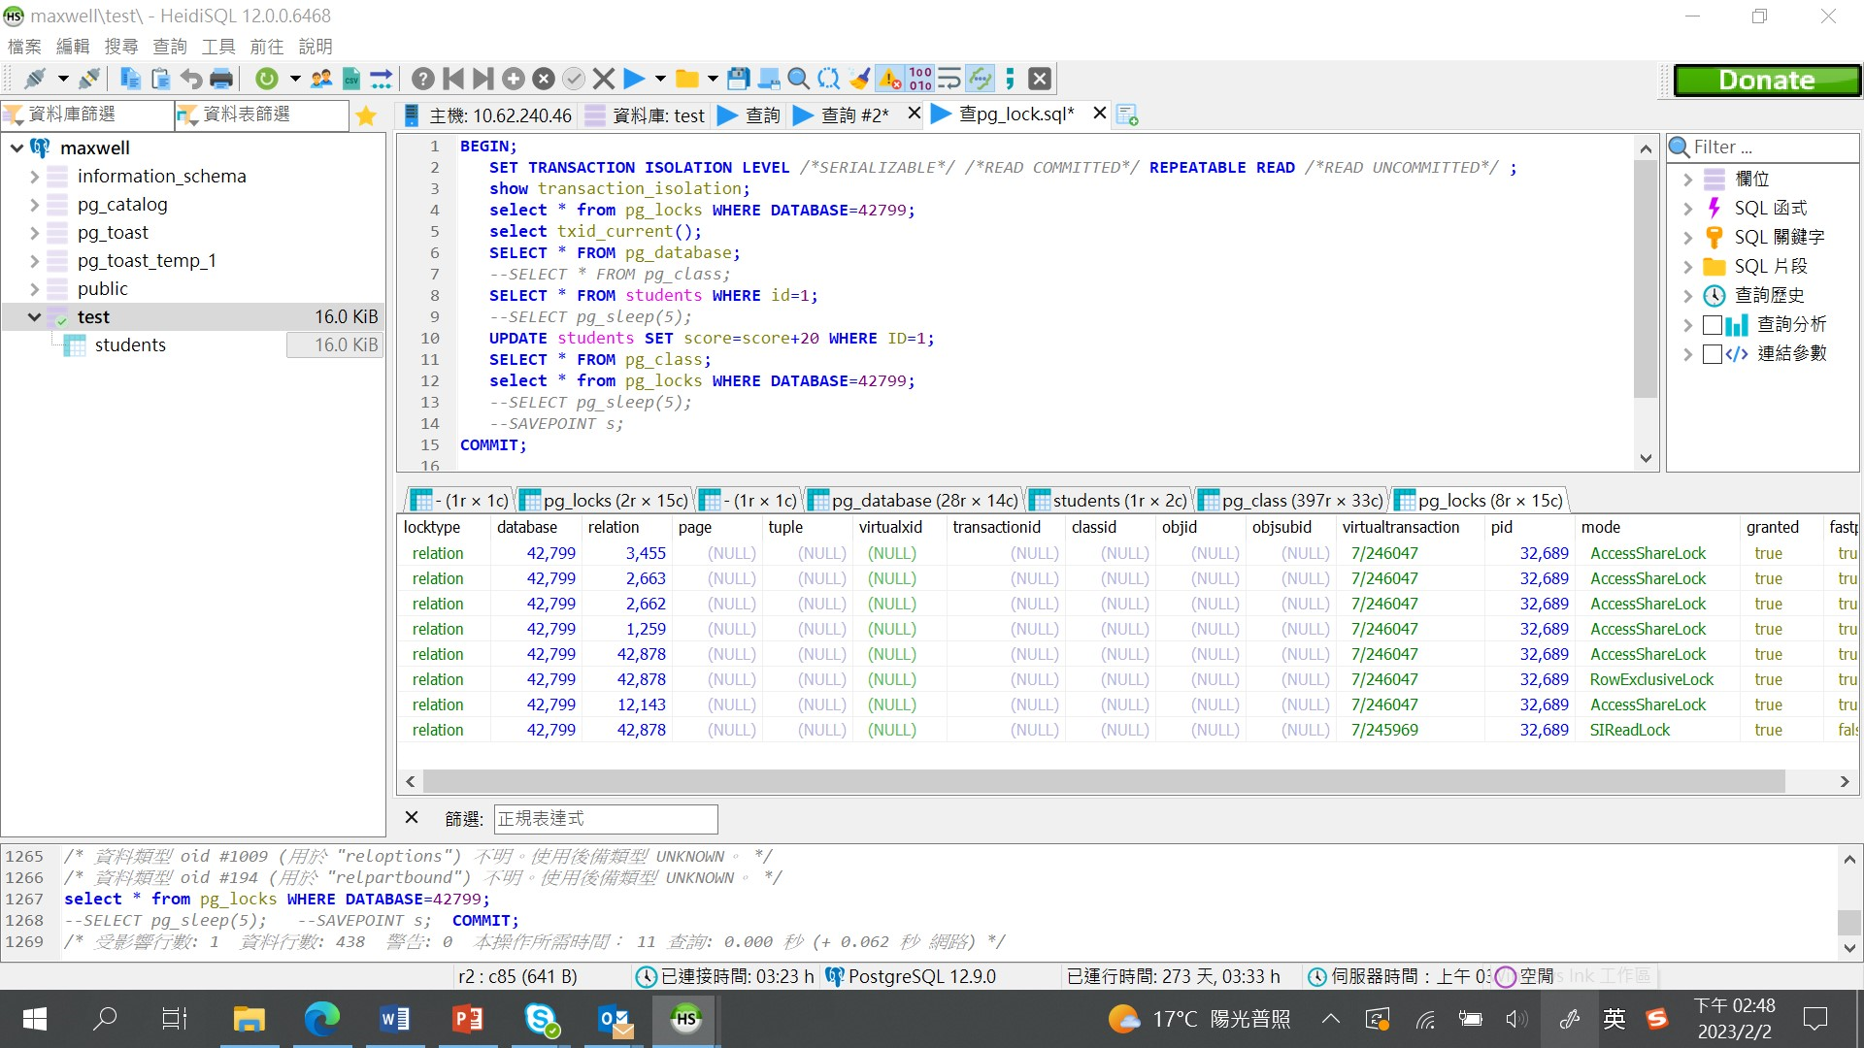

SERIALIZABLE

